Software Requirements Specification
for
Explainable Context-Aware Sprint Planning With Real-World Constraints
Version 1.0
Prepared by
Madhan karthikeyan | 23BCE0829 | madhan.karthikeyan2023@vitstudent.ac.in
Midhul Kiruthik M (Team Leader) | 23BCE0783 | midhulkiruthik.m2023@vitstudent.ac.in
Manav Kaizen | 23BCE2251 | manav.kaizen2023@vitstudent.ac.in
Sharvesh S | 23BCE2141 | sharvesh.s2023@vitstudent.ac.in
Group Name: Team ApexS

Instructor: | SWARNALATHA P
Course: | Software Engineering Lab
Lab Section: | L23+L24
Date: | 14/01/2026

Team Member | Role | Key Contributions | Contribution (%)
Midhul Kiruthik M | Team Leader | Problem formulation, system architecture, SRS consolidation, functional requirements, optimization logic, final review & integration | 35%
Madhan Karthikeyan | Team Member | Literature review, base paper analysis, product scope, assumptions & constraints, revisions section | 25%
Manav Kaizen | Team Member | Use case modeling, UML diagrams, functional requirement mapping, documentation support | 20%
Sharvesh S | Team Member | Non-functional requirements, performance & security analysis, data dictionary, IEEE SRS formatting | 20%

Contents
Contents iiI
Revisions IV
1 Introduction 1
1.1 Document Purpose 1
1.2 Product Scope 1
1.3 Intended Audience and Document Overview 1
1.4 Definitions, Acronyms and Abbreviations 2
1.5 Document Conventions 2
1.6 References and Acknowledgments 2
2 Overall Description 3
2.1 Product Overview 3
2.2 Product Functionality 4
2.3 Design and Implementation Constraints 4
2.4 Assumptions and Dependencies 4
3 Specific Requirements 5
3.1 External Interface Requirements 5
3.2 Functional Requirements 6
3.3 Use Case Model 8
4 Other Non-functional Requirements 10
4.1 Performance Requirements 10
4.2 Safety and Security Requirements 11
4.3 Software Quality Attributes 11
5 Other Requirements 13
Appendix A – Data Dictionary 13
Appendix B - Group Log 14

Revisions
Version | Primary Author(s) | Description of Version | Date Completed
1 | Midhul kiruthik M | Initial version of SRS document. | 14/01/26

Introduction
This document presents the Software Requirements Specification (SRS) for the Context-Aware Automated Sprint Planning System, a research-oriented software tool designed to support agile teams during sprint planning. The system leverages historical sprint data, contextual information, and optimization techniques to generate effective and explainable sprint plans.
This section provides an overview of the purpose, scope, intended audience, terminology, and conventions used in this document. It establishes a clear foundation for understanding the functional and non-functional requirements detailed in subsequent sections

Document Purpose
The purpose of this Software Requirements Specification (SRS) is to formally define the requirements of the Context-Aware Automated Sprint Planning System (Version 1.0). This document serves as a reference for understanding what the system is expected to do, the constraints under which it operates, and the goals it aims to achieve.
This SRS focuses on specifying the requirements of the sprint planning decision-support subsystem, rather than a complete agile project management platform. It is intended to guide system design, development, evaluation, and academic assessment as part of the Software Engineering course

Product Scope
The Context-Aware Automated Sprint Planning System is a software tool that assists Scrum teams in generating optimized sprint backlogs by analyzing historical sprint data and project context. The system considers factors such as task urgency, business value, sprint goal alignment, team capacity, and additional research extensions such as risk and skill awareness.
The primary benefits of the system include improved sprint goal alignment, reduced planning bias, better risk mitigation, and increased transparency through explainable recommendations. The objective of the product is to transform sprint planning from a manual, intuition-driven activity into a data-driven and reproducible decision-making process, thereby improving planning efficiency and outcome quality in agile software development.

Intended Audience and Document Overview
This document is intended for the following audiences:
Course Instructor / Evaluator, to assess requirement clarity and adherence to software engineering principles
Student Developers, to guide system design and implementation
Project Reviewers, to understand the scope, assumptions, and constraints of the system
The document is organized as follows:
Section 1 provides an overview of the system and document structure. Subsequent sections describe the overall system description, functional requirements, non-functional requirements, system constraints, and supporting diagrams. Readers are encouraged to begin with the introduction and then proceed to sections most relevant to their role

Definitions, Acronyms and Abbreviations

TERM | DEFINITION
Agile | An iterative and incremental software development methodology
ILP | Integer Linear Programming
PERT | Program Evaluation and Review Technique
Scrum | An agile framework for managing and completing complex projects
SRS | Software Requirements Specification
Sprint | A fixed time-boxed iteration in Scrum
Sprint Backlog | Set of tasks selected for execution in a sprint
WBS | Work Breakdown Structure

Document Conventions

This SRS document follows the IEEE recommended format and conventions. The document uses Arial font, size 11 or 12, with single-spaced text and 1-inch margins on all sides. Section and subsection numbering follows the standard IEEE hierarchy. Italics are used for explanatory comments where required, and tables are used to present structured information such as definitions and schedule

References and Acknowledgments
1. IEEE Std 830-1998, IEEE Recommended Practice for Software Requirements Specifications
2. IEEE Std 29148-2018, Systems and Software Engineering — Life Cycle Processes — Requirements Engineering
3. Context-Aware Automated Sprint Plan Generation for Agile Software Development, ASE 2024
4. Schwaber, K., & Sutherland, J., The Scrum Guide

Overall Description

Product Overview

The Context-Aware Automated Sprint Planning System is a new, self-contained decision-support software product designed to assist agile Scrum teams during sprint planning. Unlike traditional project management tools that rely heavily on manual prioritization and fixed rules, this system introduces a data-driven and context-aware approach to sprint backlog generation. It is inspired by recent research in agile planning optimization and extends existing approaches by incorporating contextual learning, optimization, and explainability.
The system is not a replacement for existing agile tools such as Jira, but rather a complementary subsystem that integrates with them. It consumes historical sprint data, contextual information, and sprint goals from external sources, processes them using learning and optimization techniques, and produces optimized and explainable sprint plan recommendations. The final sprint backlog decision remains with the Scrum team, ensuring human-in-the-loop control. At a high level, the system sits between the Scrum team and project data sources, acting as an intelligent planning assistant within the agile development environment.

High-level product interaction (illustrative):

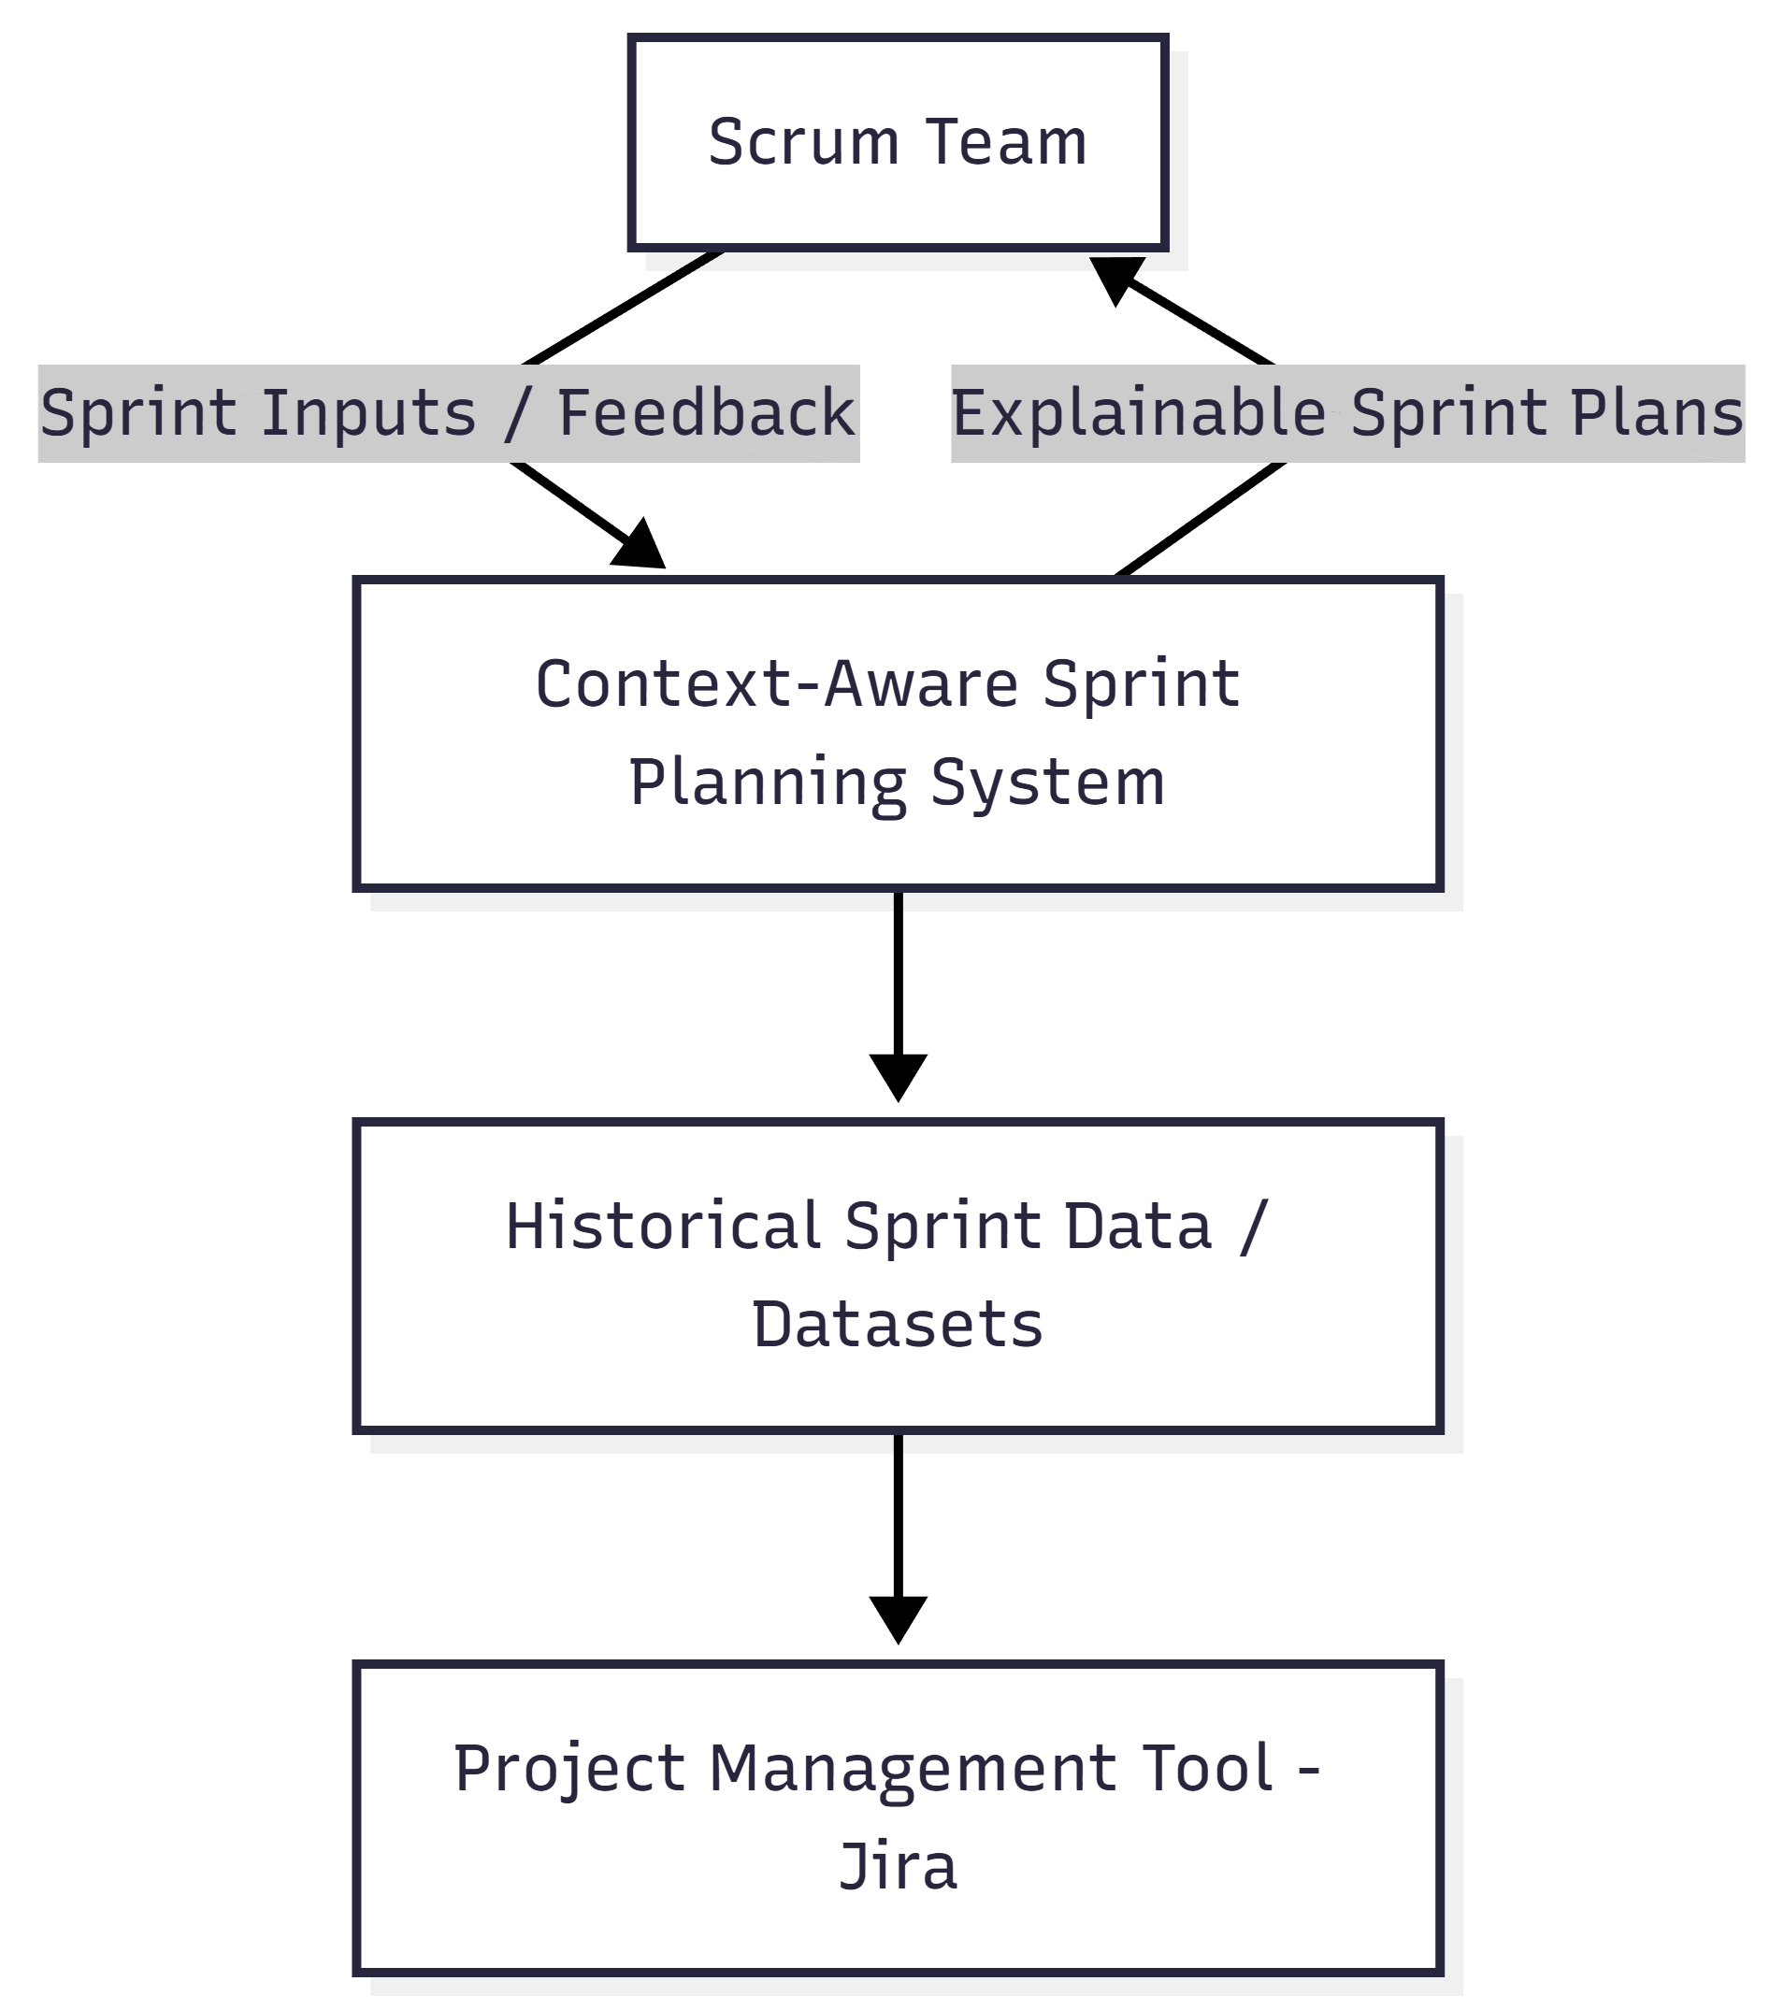

This diagram illustrates how the product interacts with users and external systems at a conceptual level.

Product Functionality
At a high level, the Context-Aware Automated Sprint Planning System provides the following major functions:
- Ingest historical sprint data from project management tools or datasets
- Extract contextual features such as team capacity, sprint goals, and task characteristics
- Learn team-specific prioritization weights based on past sprint behavior
- Generate optimized sprint backlog recommendations under capacity and dependency constraints
- Incorporate research extensions such as risk-awareness and skill-awareness
- Produce explainable justifications for each recommended user story
- Allow Scrum teams to review and finalize the sprint plan
- Generate evaluation metrics and reports for analysis and assessment
Detailed functional requirements are specified in Section 3 of this document.

Design and Implementation Constraints
The design and implementation of the system are subject to the following constraints:
- The system must be designed using the COMET (Concurrent Object Modeling and Architectural Design Method) to ensure structured object-oriented analysis and design.
- UML (Unified Modeling Language) shall be used for system modeling, including context diagrams, data flow diagrams, and design models.
- The implementation is constrained to commonly available development environments and open-source tools.
- The system must be compatible with data exported from common agile tools such as Jira.
- The solution must operate within typical academic hardware limits and should not require specialized computing infrastructure.
- Python-based technologies are preferred for data processing and optimization due to library availability and research suitability.
- The system must ensure that sensitive project data is processed securely and not exposed externally.
References:
- Gomaa, H., Designing Concurrent, Distributed, and Real-Time Applications with UML, Addison-Wesley
- OMG, Unified Modeling Language (UML) Specification

Assumptions and Dependencies
The development and operation of the system are based on the following assumptions and dependencies:
- Historical sprint data is assumed to be available, accurate, and sufficiently detailed.
- Scrum teams are assumed to follow standard agile practices such as defined sprint goals and time-boxed sprints.
- External datasets or tools (e.g., Jira exports, public agile datasets) are assumed to remain accessible throughout development.
- The system assumes that optimization results will be reviewed by humans and not automatically enforced.
- The effectiveness of the system depends on the quality and consistency of past sprint data.
- Any changes in agile processes or data formats may require adaptation of the system.
If these assumptions change or are violated, the design and results of the system may be impacted.

Specific Requirements

External Interface Requirements
This section describes how the Context-Aware Automated Sprint Planning System interacts with users, hardware, and other software systems.

User Interfaces
The system provides a web-based analytical interface intended for use by Scrum teams and evaluators during sprint planning. The interface is designed to be minimal, informative, and decision-support oriented rather than a full-fledged project management dashboard.
The primary user interface allows users to:
- Upload or select historical sprint datasets
- Specify sprint goals, capacity, and constraints
- Trigger sprint plan generation
- View optimized sprint backlog recommendations
- Inspect explainable justifications for each recommended user story
Interaction with the system is performed using standard input mechanisms such as mouse clicks, dropdown menus, and form-based inputs. Output is presented in the form of tables, ranked lists, and textual explanations. The interface is designed to support clarity and transparency rather than automation-only decision making.
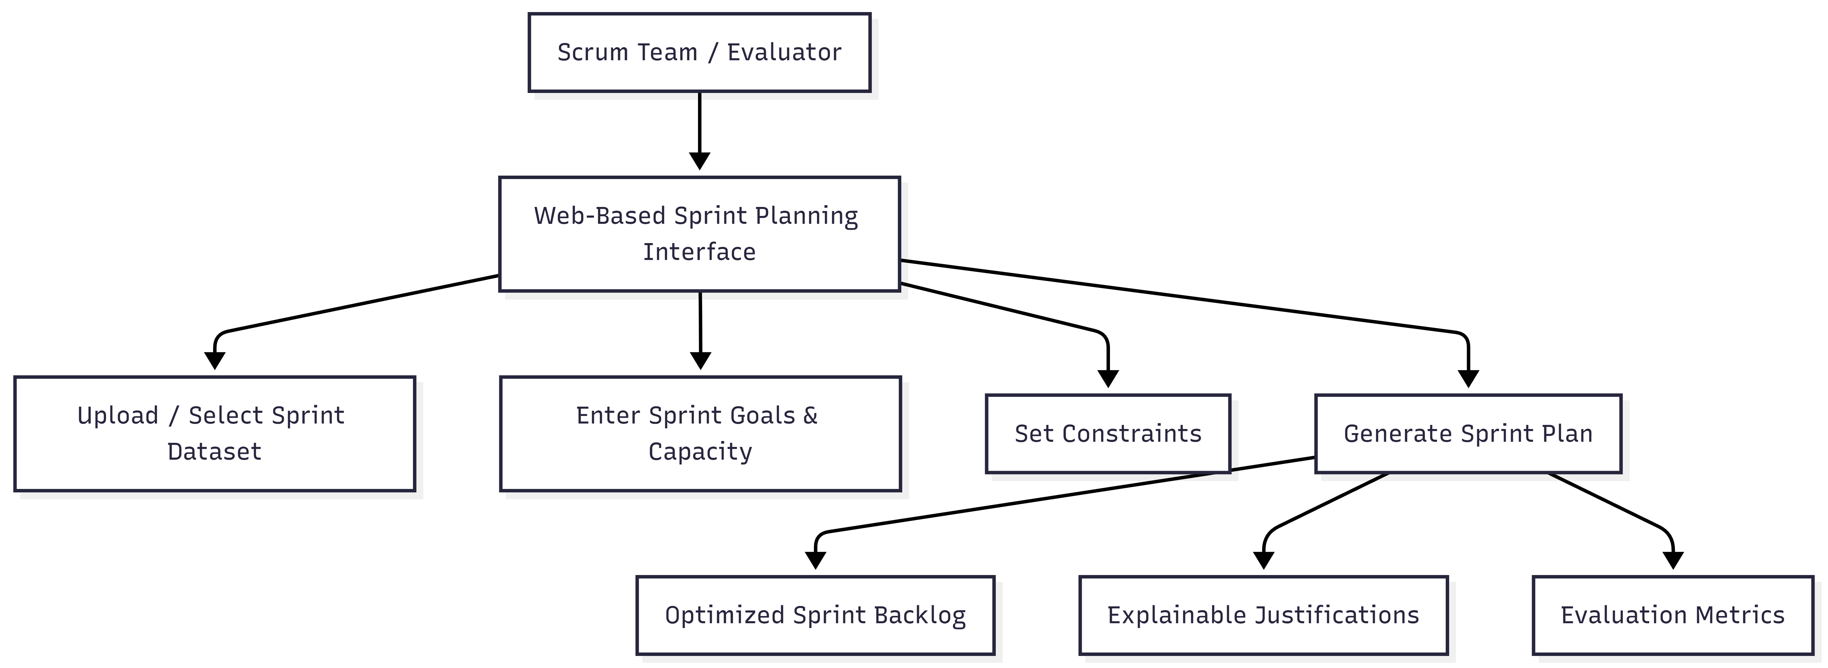

Hardware Interfaces
The system is software-based and does not directly interact with specialized hardware devices. It is expected to run on standard academic or enterprise computing environments such as personal computers or servers.
The system interfaces indirectly with hardware through:
- CPU and memory resources for data processing and optimization
- Local or cloud storage devices for storing datasets and results
No real-time hardware control or sensor-based interfaces are required. All hardware interactions are abstracted through the operating system.

Software Interfaces
The system interfaces with the following software components:
- Project Management Tools (e.g., Jira):
Used to import historical sprint data such as user stories, story points, priorities, and sprint outcomes.
- Dataset Repositories:
Public or organizational datasets (e.g., TAWOS dataset) used for training, testing, and evaluation.
- Optional Visualization Tools:
Used to display analytical outputs such as charts or reports.
All software interfaces are assumed to use file-based data exchange (e.g., CSV, JSON) or API-based communication where available.

Functional Requirements
This section specifies the detailed functional requirements of the system. Each requirement is uniquely identified and stated using “shall” statements.

F1: Historical Data Ingestion
The system shall ingest historical sprint data from project management tools or datasets.

F2: Context Extraction
The system shall extract contextual features such as team capacity, sprint goals, task urgency, and dependencies from the input data.

F3: Prioritization Weight Learning
The system shall learn team-specific prioritization weights based on historical sprint planning behavior.

F4: Sprint Plan Optimization
The system shall generate an optimized sprint backlog using capacity, dependency, and contextual constraints.

F5: Risk and Skill Awareness
The system shall incorporate risk and skill information into sprint planning as part of the research extension.

F6: Explainability Generation
The system shall provide explainable justifications for each recommended user story in the sprint plan.

F7: Sprint Plan Review
The system shall allow Scrum teams to review and manually adjust the generated sprint plan.

F8: Reporting and Evaluation
The system shall generate evaluation metrics and reports for analysis and academic assessment.

Use Case Model
The use case model captures the interactions between external actors and the system. The primary actors are the Scrum Team, Project Management Tool, and Instructor/Evaluator.
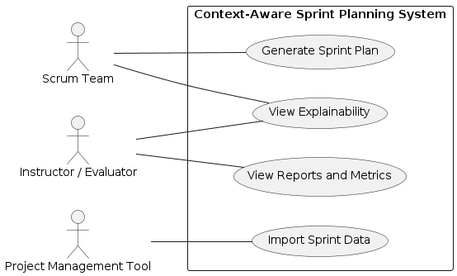

3.3.1 Use Case U1 – Generate Sprint Plan
Author: Team Member 1
Purpose:
To generate an optimized and context-aware sprint backlog based on historical data and sprint constraints.
Requirements Traceability:
F1, F2, F3, F4, F5
Priority: High
Preconditions:
- Historical sprint data is available
- Sprint goals and team capacity are defined
Postconditions:
- An optimized sprint plan is generated and stored
Actors:
- Scrum Team
- Project Management Tool
Extends: None

Flow of Events
Basic Flow:
- The Scrum Team provides sprint goals and capacity.
- The system loads historical sprint data.
- Contextual features are extracted.
- Prioritization weights are learned.
- The system generates an optimized sprint plan.
Alternative Flow:
- If historical data is incomplete, default weights are applied.
Exceptions:
- Invalid or missing data results in an error message.
Includes:
- U2: Generate Explainability
Notes/Issues:
Quality of output depends on historical data quality.

3.3.2 Use Case U2 – View Explainable Sprint Plan
Author: Team Member 2
Purpose:
To allow users to understand why specific user stories were selected.
Requirements Traceability:
F6, F7
Priority: Medium
Preconditions:
- A sprint plan has been generated
Postconditions:
- Explainability information is displayed
Actors:
- Scrum Team
- Instructor / Evaluator
Extends: U1

Flow of Events
Basic Flow:
- User selects a sprint plan.
- System displays explanations for each user story.
Alternative Flow:
- User filters explanations by risk or value.
Exceptions:
- Explanation data unavailable.
Includes: None
Notes/Issues:
Explainability is essential for trust and adoption.

Other Non-functional Requirements

Performance Requirements
The system is intended to support sprint planning activities and therefore must deliver results within reasonable time limits to avoid disrupting Scrum ceremonies.
- P1: The system shall generate an optimized sprint plan within 10 seconds for datasets containing up to 5,000 user stories.
- P2: Context extraction and preprocessing shall complete within 5 seconds for standard sprint datasets.
- P3: The explainability module shall produce explanations for all selected user stories within 2 seconds after plan generation.
- P4: The system shall support concurrent access by at least 5 users without noticeable performance degradation.
These requirements ensure that the system can be effectively used during real-time sprint planning meetings.

Safety and Security Requirements
Although the system does not control physical devices, safety and security are critical due to the use of project and organizational data.

Security Requirements
- S1: The system shall restrict access to authorized users only.
- S2: User authentication shall be required before accessing sprint data or generating plans.
- S3: Project data shall not be shared with external systems without explicit user consent.
- S4: All uploaded datasets shall be processed locally or within a secure execution environment.
- S5: The system shall prevent unauthorized modification of historical sprint data.

Safety Requirements
- SA1: The system shall function strictly as a decision-support tool and shall not automatically enforce sprint plans.
- SA2: Users shall always have the ability to override or modify system recommendations.
- SA3: In case of system failure, manual sprint planning shall remain unaffected.

Software Quality Attributes

4.3.1 Reliability
- The system shall consistently generate valid sprint plans without data corruption.
- Error handling mechanisms shall ensure graceful failure in case of invalid inputs.
- System outputs shall be reproducible for identical inputs.

4.3.2 Maintainability
- The system shall be modular, separating data processing, optimization, and explainability components.
- Code shall follow standard software engineering conventions to enable future enhancements.
- UML and COMET-based design artifacts shall support easier maintenance and evolution.

4.3.3 Usability
- The user interface shall present sprint plans and explanations in a clear and understandable format.
- Minimal training shall be required for Scrum teams to use the system effectively.
- Explanations shall prioritize clarity over technical complexity.

4.3.4 Adaptability
- The system shall support different agile team configurations and project types.
- New prioritization criteria (e.g., quality, compliance) shall be integrable with minimal redesign.
- Dataset formats may be adapted through configurable preprocessing modules.

Other Requirements
Data Storage Requirements:
Sprint data and generated plans shall be stored in structured formats such as CSV or JSON.
Reusability:
The optimization and explainability modules shall be reusable for future research or extensions.
Legal and Ethical Considerations:
The system shall comply with institutional data usage policies and academic integrity guidelines.

Appendix A – Data Dictionary

Name | Type | Description | Related Requirement
SprintGoal | Input | Objective defined for a sprint | F2
TeamCapacity | Input | Available team effort for sprint | F2
StoryPoints | Input | Effort estimate of a user story | F1
RiskScore | State | Estimated risk level of a story | F5
SkillTag | State | Skill requirement of a story | F5
PriorityWeight | State | Learned importance of criteria | F3
SprintPlan | Output | Generated sprint backlog | F4
Explanation | Output | Justification for story selection | F6

Appendix B - Group Log

Meeting 1
- Topic: Base paper analysis and problem statement
- Outcome: Research gap finalized

Meeting 2
- Topic: Process model, context model, and DFDs
- Outcome: Scrum-based process and system models finalized

Meeting 3
- Topic: Scheduling artifacts (Gantt, Timeline, WBS, PERT)
- Outcome: Project plan approved

Meeting 4
- Topic: SRS writing and review
- Outcome: Final SRS consolidated and reviewed by all members

